**Data Visualization - Property Theft Data.**

**Name : Praveena Angolla**

**Student Id : 22092233**

**Mail :** [**pa23aar@herts.ac.uk**](mailto:pa23aar@herts.ac.uk)

**Git Hub link:**

**Data Source:** <https://www.kaggle.com/datasets/rajanand/crime-in-india?select=10_Property_stolen_and_recovered.csv>

# Property Cases Recovered in Assam and Chandigarh

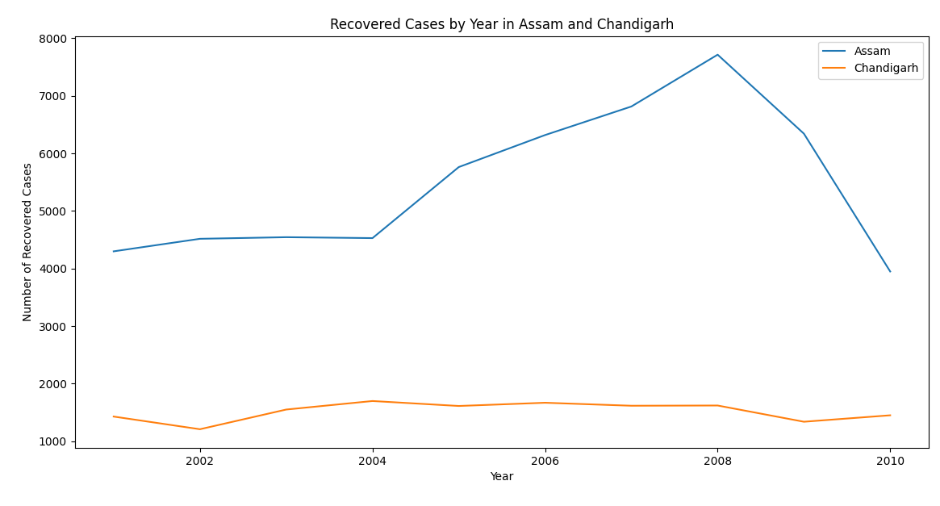

The above line chart basically provides a comparison line between two cities about the property recovered cases by year. It can be observed that Chandigarh has a very low ratio of such recovered cases, while Assam has a decline in their number of cases just after 2008.

# Groups with Property Stolen Cases By Value

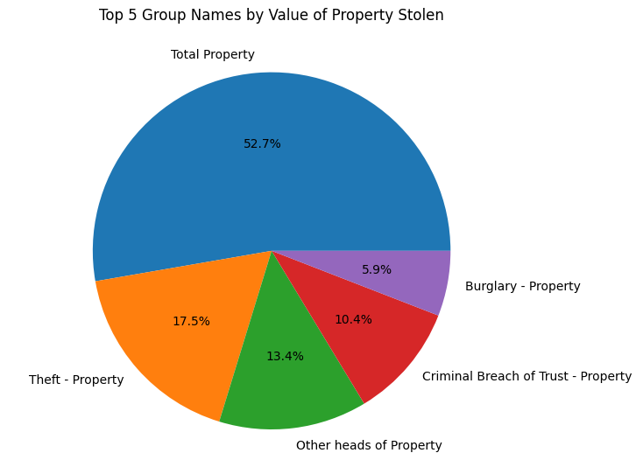

This visual of pie chart is providing top 5 group names who are involved in expensive property stolen cases and have done higher levels of crime related to property. Such visualization is necessary for the concerned departments to keep the record which can be beneficial for them to trace such groups. In the future, strict action can be taken to tackle these groups.

# Bihar And Delhi Comparison

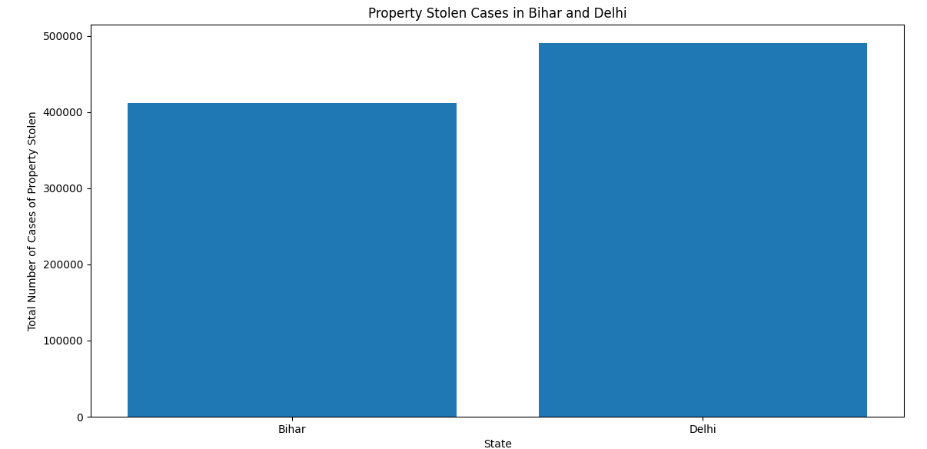

It is important to keep an eye on some cities and number of crimes occurred in them. This bar graph visualization shows a comparison of two cities in India Delhi and Bihar in which it can be seen that Property stolen cases in Delhi are higher than Bihar.